Alcohol, Vol. 10, pp. 213-217, 1993 0741-8329/93 $6.00 + .00
Printed in the U.S.A. All rights reserved. Copyright ^{c} 1993 Pergamon Press Ltd.
Changes of Auditory-Evoked Potentials in
Response to Behaviorally Meaningful Tones
Induced by Acute Ethanol Intake in
Altricial Nestlings at the Stage of
Formation of Natural Behavior
LEONID I. ALEXANDROV*¹ AND YURI I. ALEXANDROV^
*¹Institute of Higher Nervous Activity and Neurophysiology and ^Institute of Psychology, Russian Academy of Sciences, Moscow, Russia
Received 16 March 1992; Accepted 9 December 1992
ALEXANDROV, L. I. AND Y. I. ALEXANDROV. Changes of auditory-evoked potentials in response to behaviorally meaningful tones induced by acute ethanol intake in altricial nestlings at the stage of formation of natural behavior. ALCOHOL 10(3) 213-217, 1993.- Acute ethanol's influence on field L auditory-evoked potentials (AEP) was studied in 4-7-days-old altricial nestlings of the pied flycatcher. Nestlings were presented with behaviorally meaningful tone pips (2.0 and 5.0 kHz) and control tone pips (3.0 kHz). Ethanol ingestion was found to reduce the Nj amplitude and maturity index (MI) of the AEP in response to "behavioral" but not to control frequencies. This effect was first observed on day 5, when the nestlings' behavior became more complex (their eyes opened and defence behavior appeared), and when previously formed feeding behavior was undergoing modifications. The MI increase during the early postembryonic ontogeny was probably due to the selective involvement of neurons with newly formed behavioral specializations into the subserving of new behavioral patterns, while the decrease of the MI under alcohol was due to the depression of activity in these neurons.
Ethanol Auditory-evoked potentials Ontogeny Natural behavior

ONTOGENY of altricial tree-hole nestlings is a convenient model to study the development of behavior and the morpho-genetic processes underlying it. Pied flycatcher nestlings hatch with their eyes and external acoustical meatuses closed. During the first 4 days of life, their behavioral repertoire is represented by a sole behavioral pattern —begging. Feeding behavior at this time is elicited only be acoustical signals —by the complex of sounds produced by arriving parents and their species-typical "food call" (11). The hearing range of the young at this age is limited to low and medium frequencies (0.1-4.0 kHz). In nestlings with a high level of feeding motivation, begging may be elicited by tone pips within all their hearing range. However, the optimal frequency is 2.0 kHz (12).
On day 5, nestlings' eyes begin to open and begging appears to be increasingly more related with luminosity change in the nestbox caused by the arrival of an adult bird (11), but 2.0-
kHz tone pips are still extremely effective stimuli for begging. Simultaneously with an AEP threshold decrease in the low and medium frequency ranges, the sensitivity to high frequencies starts to mature (initially 5.0-6.0 kHz, and later up to 8.0 kHz) (1). The period characterized by eye opening and by the change in the triggering stimulation of feeding behavior is also the time of change in the young's behavioral repertoire. From day 5 onward, nestlings begin to display the defence response (freezing) to the parents' alarm call (11). This defence response may be provoked by 5.0-kHz tone pips rhythmically repeated at the rate of 1-2 per 1 s.
An analysis of the AEP from field L of the caudal neostria-tum (a higher avian auditory integrative structure analogous to mammalian auditory cortex; see 17) in flycatcher nestlings in response to tone pips revealed a regular modification of the waveform with age: Nj amplitude increased, whereas response duration and latency decreased (12). To describe quantita-

¹ Requests for reprints should be addressed to Dr. L. Alexandrov, Institute of Higher Nervous Activity and Neurophysiology, Russian Academy of Sciences, 117485 Butlerova str., 5^{A}, Moscow, Russia.
213

214 ALEXANDROV AND ALEXANDROV

tively the waveform of the evoked potential, an amplitude-temporal coefficient was introduced, signifying the relation of the amplitude of the N₁-P₂ limb of AEP to the P₁-P₂ latency difference. An analysis of its dynamics revealed a high degree of correlation of its change (increase) with the age of the young bird (12). This suggested that this coefficient was an integral index of AEP maturation, characterizing temporal and amplitude parameters simultaneously.
A heterochronous maturation of AEP in response to different frequencies and the relation of AEP changes with the reorganization of nestlings' behavioral repertoire (1,12) suggested that age dynamics of the AEP reflected the selective maturation of neuronal elements subserving newly formed behavior. To test this hypothesis, nestlings were fed with mealworms containing ethanol. Alcohol has been previously shown to depress selectively the activity of the neurons subserving the realization of the newest behavioral acts (3).
METHOD
Setup and Stimulation
Data were collected in our field research laboratory in Oka-Terrace Reserve (100 km south of Moscow) using 24 pied flycatcher nestlings (Ficedula hypoleuca) aged 4-7 days. Prior to the beginning of an experiment, nestlings were raised by their parents in the wild.
Nestlings were tested while sitting in a nest in a wire cage installed in a soundproof anechoic chamber. The temperature in the nest was automatically maintained at the comfort level (39°C) that was determined by field measurements. The auditory stimuli were 2.0-, 3.0-, and 5.0-kHz tone bursts of 17 ms duration (rise/fall 1.7 ms) and 88 dB sound pressure level (SPL) (above 0.00002 Pa) generated by an oscillator and processed by the computer-controlled phase-locking gating device. Stimulus form and intensity were monitored with a Ro-botron Spectroanalyzer and Bruel & Kjaer Sound Level Meter. The main tone exceeded the harmonics by no less than 40 dB. Tone pips were delivered via a hi-fi isodynamic headphone speaker that was installed 12 cm above the nestling's head. The control (behaviorally nonmeaningful) frequency of 3.0 kHz was approximately equally positioned with respect to both behaviorally meaningful tones of 2.0 and 5.0 kHz. That is, the difference between the 2.0- and 3.0-kHz tone bursts was about 0.6 octaves, and the difference between the 5.0-and 3.0-kHz tone bursts was about 0.7 octaves. To ensure that postalcohol recordings were made with relatively constant BAL, an attempt was made to minimize the duration of each recording session. That is why the inter stimulus intervals used (constant within each series) were the shortest possible for each age. They ranged from 4 s for the older nestlings to 20 s for the younger ones, making the total time of a postalcohol AEP recording 5 to 25 min. Stimuli presentation at a higher rate could result in fatigue of responses.
Before the control (i.e., predrug) AEP recording, nestlings received their standard portion of food —a mealworm. After the control recordings, nestlings were given a mealworm that had been injected with ethanol immediately before that. The doses 1-1.2 g per 1 kg of a nestling's body weight were used. After 5 min, AEPs in response to all three frequencies were recorded again. It was impossible to monitor blood alcohol level, but the quasi-random presentation of the series of different tone pips minimized the effect of possible differences in blood ethanol concentrations. The same nestling was never
used in experiment more than once in a day. Each nestling was used in 1 to 4 experiments.
Recording
Field L AEPs were recorded bipolarly in awake unrestrained nestlings through silver ballpoint electrodes (uninsulated ball tips 0.3 mm in diameter) that were implanted under Nembutal anaesthesia (90 mg/kg, i.p.) in field L of each hemisphere. A reference electrode (uninsulated silver wire 0.3 mm in diameter) was implanted subdurally along the midline of the cerebellum. After amplification and filtration (bandpass 1-150 Hz), the signal was fed to an IBM PC (25 trials, acquisition epoch 250 ms synchronized with the stimulus onset, bin width 1 ms). Individual trials were saved for the further processing. Peak amplitudes and latencies were manually defined for individual responses. The mean value of any parameter in each series was based on the average of the 25 individual values.
To eliminate the influence of high interindividual variability of AEP parameters, data were processed as follows. The mean value of any parameter of AEP recorded in response to each frequency in a given recording session after alcohol intake was divided by the corresponding mean value derived from the control recording that immediately preceded ethanol ingestion. Resulting ratios were combined and averaged for each age and frequency. This procedure made it possible to estimate the alcohol effect on any AEP parameter. An averaged ratio higher than 1 demonstrated the increase of a parameter value after alcohol intake, whereas a ratio lower than 1 was an indication of its decrease. A two-tailed t test (Statistical Graphics System, version 3.0, one-sample analysis) was used to analyze the statistical significance of the difference between the averaged ratios and 1. When the non-normalized pooled data were compared, a two-sample analysis Mest procedure was utilized. Differences were considered significant at P < 0.05.
Nestlings were used in experiments for a period from 1 to 4 days depending on the changing position of the recording electrodes, which were gradually drifting away from the center of the field L in the rapidly growing nestlings' brains. After
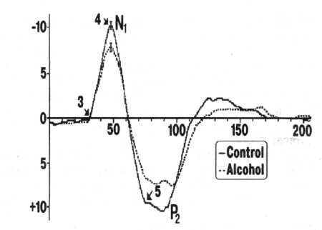
FIG. 1. Averaged AEP of a 5-day-old nestling in response to 5-kHz tone pips before (solid line) and 10 min after (dashed line) alcohol intake. Horizontal axis = time (ms). Epoch begins at the onset of the tone. Vertical axis = amplitude (µV). Upward deflection is negative. Vertical bars on the N, peak indicate SE. Each AEP is an average of 25 trials. Arrows indicate points used for the calculation of the maturity index.

MATURATION OF AUDITORY EP AND ALCOHOL 215

the experiments, some nestlings were sacrificed for morphological verification of electrode positions within field L. Other nestlings, after the recording electrodes were removed and the wound healed, were returned to their nests and fledged normally thereafter.
RESULTS
Field L AEP were recorded as a P₁-N₁-P₂ complex. The primary positive peak was the most variable of all and was observed only in a minority of responses. Therefore, it was rarely observed in averaged traces (Fig. 1).
The maturity index (MI) of only the most stable part of a response (N₁ was estimated. The MI equalled the difference between amplitudes at points 4 and 5 divided by the latency difference between points 3 and 5 (see Fig. 1). This method of calculation yielded the same pattern of developmental changes as that reported by Khayutin and Dmitrieva (12) for the amplitude-temporal coefficient, and enabled us to reduce the variability of the resulting index.
At the first stage of the analysis, the corresponding parameters of the AEP elicited by the same frequency in the nestlings of the same age were combined. No significant latency changes were observed in responses to any frequency at any age.
An overall pattern of the N₁ amplitude and MI changes was always a decrease of both parameters following alcohol
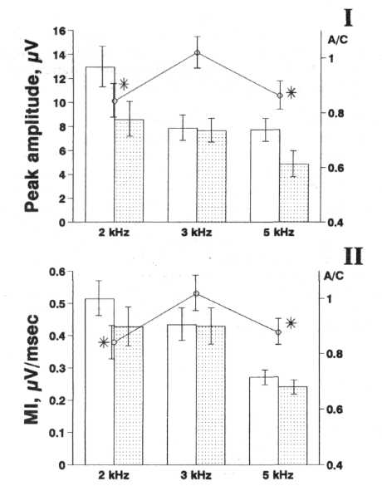
FIG. 2. Influence of alcohol on the amplitude (above) and MI (below) of AEP in 5-day-old nestlings. Horizontal axis = frequency (kHz). Left vertical axis = N₁, amplitude (µV) and MI ((µV/ms); right vertical axis = ratio alcohol/control for the respective parameter. Open bars = control; dotted bars = after alcohol intake (pooled data). Lines = ratio alcohol/control (A/C, normalized data). ♦Significant difference of AEP parameters before versus after alcohol intake (for normalized data, A/C). Error bars = SE.
intake (however, the decrease for AEPs in response to 3.0-kHz pips was very unsubstantial). The only exception was N₁ amplitude in response to 5 kHz on day 4 (AEP amplitude increased after ethanol ingestion). An example of the changes of the mean N₁ amplitude and MI induced by ethanol on day 5 based on the pooled data is presented in Fig. 2 (bars).
Like other authors (e.g., 7), we observed a high variability in the evoked potentials that is typical for the early ontoge-netic period. Consequently, further data analysis was performed to study the dynamics of the AEP parameters after the data normalization procedure described in Methods.
Tables 1 and 2 present mean ± SE post-/pre-alcohol ratios for the N, amplitude and MI of AEP based on the normalized data.
Table 1 presents the effect of alcohol intake on the N₁ amplitude in responses to 2.0, 3.0, and 5.0 kHz at different ages. It can be seen that across days 4 to 7 the significant decrease of AEP amplitude was observed only on day 5, and only in AEPs in response to behaviorally meaningful frequencies (2.0 and 5.0 kHz).
Table 2 shows that ethanol-induced change of the MI of AEP to the tone pip of the control frequency (3.0 kHz) was also insignificant in the young of any age. Changes of the MI in responses to 2.0 and 5.0 kHz on day 4 were also insignificant. On day 5, however, alcohol intake induced a significant decrease of the MI in response to frequencies meaningful for feeding (2.0 kHz) and defence (5.0 kHz) behavior. An analysis of the age dynamics of the MI in intact nestlings proved that between days 4 and 5 this index significantly increased in responses to both behavioral and control frequencies (i.e., the normal tendency of its change was the same in responses to all frequencies used).
On day 6, ethanol intake still induced a statistically significant decrease of the MI in responses to both behavioral frequencies, whereas on day 7 the only significant effect of alcohol was the decrease of the MI in response to the 2.0-kHz tone pip.
DISCUSSION
Ethanol's influence upon the functional characteristics of the auditory system has been demonstrated for different parts of the auditory pathway. It was shown in experiments based on recordings of both auditory-evoked potentials (8,9,14) and auditory brainstem responses (4,5,6).
Alcohol intake induced a depression of evoked auditory responses (8,9,14,15), and this effect could be observed even with a comparatively low ethanol dose of 0.4 g/kg (9). It was suggested that the effect of alcohol could be mediated by hypothermia, as the stabilization of body temperature after alcohol intake resulted in no change of response latency (10). On the other hand, temperature-independent changes in the peak latencies of auditory brainstem responses following alcohol intake were found in humans (5,20) and animals (13). It is well established that the parameters of auditory responses in birds are extremely sensitive to the changes of body temperature (18), and thus this aspect of alcohol effect seems especially important. However, a detailed study (13) utilizing the control of both blood alcohol level and brain temperature revealed that ethanol had a direct, temperature-independent effect soon after alcohol intake and during the plateau of the blood alcohol level curve, as well as an indirect, temperature-dependent effect when blood alcohol concentration was decreasing. The depressive effect of alcohol on the AEP observed in our experiments must be a direct one —first, because

216 ALEXANDROV AND ALEXANDROV
TABLE 1
INFLUENCE OF ACUTE ALCOHOL INTAKE ON N₁ AMPLITUDE OF THE AEP IN NESTLINGS AT DIFFERENT AGES (RATIO ALCOHOL/CONTROL)

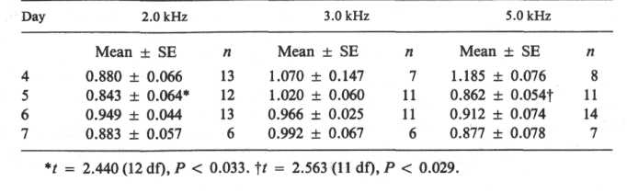

its influence was frequency-selective; second, it was age-specific (compare day 5 and 7, Tables 1 and 2); and third, responses were recorded in altricial nestlings with immature thermocontrol mechanisms (19) who were sitting in the chamber with a precisely controlled constant temperature.

The significant effect of ethanol on the parameters of field L AEP was first observed in 5-day-old nestlings. At that age, the nestlings' eyes begin to open and their behavior radically changes, especially the organization of their feeding behavior. By day 9, along with the diffuse luminosity change, a moving silhouette of a bird becomes the meaningful factor for feeding behavior (11). In other words, during days 5-7 of nest life, the feeding behavior of nestlings undergoes gradual changes in relation with its sensory basis —that is, their behavior is now reorganized with respect to the visual environment and starts interacting with a defence response (11,12). The new behavioral pattern (i.e., defence behavior) starts to appear on day 5. In the wild, it is elicited by the rhythmically organized alarm call of the adults. The energy maximum of the call corresponds to 5.0-5.5 kHz. During the next few days, defence behavior remains relatively fixed (11). Thus, after day 5, high frequency auditory sensitivity is not directly related to feeding behavior. Conversely, nestlings presented with 5.0-kHz tone pips with the repetition rate of 1-2 per second stop begging, suppress vocalization, and freeze. Thus, behavioral changes occurring on day 5 may be summarized in the following way: 1) Feeding behavior becomes more complex; 2) the behavioral repertoire of the young is enriched (i.e., a new defence behavior appears); and 3) feeding and defence behavior begin to interact on the basis of the feeding motivation of the nestlings (11).
The amplitude and the MI of the tone-elicited AEP in intact nestlings significantly increased also on day 5 as compared
to those on day 4. Thus, the significant increase in the amplitude and the MI coincided with the first occurrence of the significant alcohol effect —a decrease of the MI of AEP elicited by the behaviorally meaningful tones (i.e., with the MI shift in the direction of less "mature" values). The number of neurons involved in the subserving of behavior is decreased after the acute ethanol intake. This decrease is due to the selective depression of activity in those units that subserve the realization of the newest behavioral acts (3). The MI change and the growth of the AEP amplitude coincide with the appearance of the new forms of behavior. These changes may be due to the involvement of the new, previously inactive neurons and/or neurons with the newly formed behavioral specialization in the subserving of the newly formed behavior. It is these neurons that appear to be the most susceptible to the influence of ethanol. Thus, it may be suggested that the increase of the amplitude-temporal coefficient (MI) during the course of ontogeny reflects the selective maturation of neuronal elements involved in the realization of the new behavioral patterns.
Another fact observed in this study (i.e., on day 5 alcohol intake affected only the responses to the behaviorally meaningful frequencies while the N, amplitude and MI in the control nestlings between days 4 and 5 increased in the AEP responses to all frequencies) may be correlated with the results obtained in the study of the effects of ethanol on the evoked potentials in human subjects. The study of event-related potentials has revealed the dependence of an alcohol effect on the behavioral role of a stimulus — the responses to target stimuli were found to be more susceptible to alcohol's influence than the responses to meaningless ones (16). These differences may be due to the fact that the AEP in response to behaviorally meaningful and meaningless tone pips could reflect the

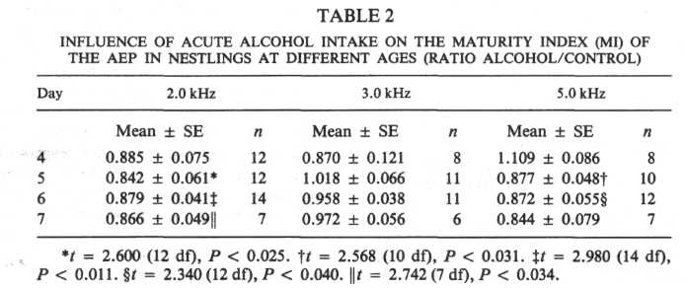
MATURATION OF AUDITORY EP AND ALCOHOL 217

activity of neuronal elements with different characteristics (e.g., the role of neurons with newly formed specialization in the subserving of an unidentified behavior elicited by the control frequency may be very unsubstantial). Nevertheless, parallel increases of the AEP amplitude and MI in response to both behavioral and control frequencies makes possible the supposition that the sets of neurons basic for the compared AEP at least partially overlap. In connection with this another, not necessarily alternative, mechanism of alcohol influence on AEP elicited by behavioral and control frequencies may be suggested: Dis-
charges of the same neurons in our experimental situation may have different genesis and, as a result, may be differentially susceptible to the influence of ethanol (2).
The above discussion makes it possible to conclude that the dynamics of the amplitude-temporal coefficient — MI— reflect the essential ontogenetic changes of the neuronal mechanisms related with the gradual maturation of the behavioral repertoire, newly formed elements of which appear to be most susceptible to the influence of ethanol as is the case with adult animals.

REFERENCES

- Alexandrov, L. I.; Dmitrieva, L. P. Development of auditory
sensitivity in altricial nestlings. Absolute thresholds of the genera
tion of evoked potentials. Neurosci. Behav. Physiol. 22:132-137;
1992.
- Alexandrov, Y. I.; Grinchenko, Y. V.; Laukka, S.; Jarvilehto,
Т.; Maz, V. N. Acute effect of ethanol on unit activity in the
motor cortex of freely moving rabbits: Comparison with the lim-
bic cortex. Acta Physiol. Scand. 142:429-435; 1991.
- Alexandrov, Y. I.; Grinchenko, Y. V.; Laukka, S.; Jarvilehto,
Т.; Maz, V. N.; Svetlaev, I. A. Acute effect of ethanol on the
pattern of behavioral specialization of neurons in the limbic cor
tex of the freely moving rabbit. Acta Physiol. Scand. 140:257-
268; 1990.
- Campbell, K.; Studart-Marangoni, C; Walsh, C; Baribeau-
Braun, J. The effects of alcohol on the human auditory evoked
potential and signal detection. Psychophysiology 18:176-182;
1981.
- Church, M. W.; Williams, H. L. Dose and time dependent effects
of ethanol on brain stem auditory evoked responses in young
adult males. Electroencephalogr. Clin. Neurophysiol. 54:161-
174; 1982.
- Church, M. W.; Williams, H. L.; Holloway, J. A. Brain-stem
auditory evoked potentials in the rat: Effects of gender, stimulus
characteristics and ethanol sedation. Electroencephalogr. Clin.
Neurophysiol. 59:328-340; 1984.
- Farber, D. A. Funktsionalnoye sozrevaniye mozga v rannem on-
togeneze [Functional maturation of the brain in early ontogeny].
Moscow: Prosvescheniye; 1969.
- Gross, M. M.; Begleiter, H.; Tobin, M.; Kissin, B. Changes in
auditory evoked response induced by alcohol. J. Nerv. Ment Dis.
143:152-156; 1966.
- Hari, R.; Sams, M.; Jarvilehto, T. Effects of small ethanol doses
on the auditory evoked transient and sustained potentials in the
human EEG. In: Begleiter, H., ed. Biological effects of alcohol.
New York: Plenum Press; 1980:579-587.

- Jones, T. A.; Stockard, J. J.; Weidner, W. J. The effect of
temperature and acute alcohol intoxication on brainstem auditory
evoked potentials in the cat. Electroencephalogr. Clin. Neuro
physiol. 49:23-30; 1980.
- Khayutin, S. N. Sensory factors in the behavioral ontogeny of
altricial birds. In: Rosenblatt, J. S., ed. Advances in the study of
behavior, vol. 15. New York: Academic Press; 1985:105-152.
- Khayutin, S. N.; Dmitrieva, L. P. Organizatsiya rannego vidos-
pecificheskogo povedeniya [Organization of the early species-
specific behavior]. Moscow: Nauka; 1991.
- Lee, J. A.; Schoener, E. P.; Nielsen, D. W.; Kelly, A. R.; Lin,
W.-N.; Berman, R. F. Alcohol and the auditory brain-stem re
sponse, brain temperature and blood alcohol curves: Explanation
of a paradox. Electroencephalogr. Clin. Neurophysiol. 77:362-
375;1990.
- Nakai, Y. Effects of intravenous infusion of central depressants
on evoked potentials of the auditory cortex of cats. Jap. J. Phar
macol. 14:235-255; 1964.
- Perrin, R. G.; Hockman, С. Н.; Kalant, H.; Livingston, К. Е.
Acute effects of ethanol on spontaneous and auditory evoked
electrical activity in cat brain. Electroencephalogr. Clin. Neuro
physiol. 36:19-31; 1974.
- Rohrbaugh, J. W.; Stapleton, J. M.; Parasuraman, R.; Zubovic,
E. A. Dose-related effects of ethanol on visual sustained attention
and event-related potentials. Alcohol 4:293-300; 1987.
- Rubel, E. W. Ontogeny of auditory system function. Ann. Rev.
Physiol. 46:213-229; 1984.
- Schermuli, L.; Klinke, R. Change of characteristic frequency of
pigeon primary auditory afferents with temperature. J. Сотр.
Physiol. 156:209-211; 1985.
- Schilov, I. A. Regulatsiya teploobmena u ptits [Avian thermocon-
trol]. Moscow: Moscow University Press; 1968.
- Squires, К. С; Chu, N.-S.; Starr, A. Acute effects of alcohol on
auditory brainstem potentials in humans. Science 201:174-176;
1978.

