Act a Physiol Scand 1990, 140, 257-268
Acute effect of ethanol on the pattern of behavioural specialization of neurons in the limbic cortex of the freely moving rabbit
YU. I. ALEXANDROV, YU. V. GRINCHENKO, S. LAUKKA, T.JARVILEHTO*, V. N. MAZ** and I. A. SVETLAJEV***
Institute of Psychology, USSR Academy of Sciences, Moscow, USSR, * Department of Behavioural Sciences, University of Oulu, Finland, ** Institute of Higher Nervous Activity, USSR Academy of Sciences, Moscow, USSR, and ***J All Union Centre for Narcology, Ministry of Health of the USSR, Moscow, USSR
Alexandrov, Yu. I., Grinchenko, Yd. V., Laukka, S., Jarvilehto, Т., Maz, V. N. & Svetlajev, I. A. 1990. Acute effect of ethanol on the pattern of behavioural specialization of neurons in the limbic cortex of the freely moving rabbit. Acta Physiol Scand 140, 257-268. Received 1 March 1990, accepted 9 May 1990. ISSN 0001-6772. Institute of Psychology, USSR Academy of Sciences, Moscow, USSR, Department of Behavioural Sciences, University of Oulu, Finland, Institute of Higher Nervous Activity, USSR Academy of Sciences, Moscow, USSR, and All Union Centre for Narcology, Ministry of Health of the USSR, Moscow, USSR.
Single-unit activity was studied in the limbic cortex of eight freely moving rabbits in order to find out what kind of changes in the organization of unit activity correlate with behavioural disturbances following an acute administration of ethanol (1 g kg"¹). The rabbits were taught to acquire food by pressing pedals in the experimental cage. Unit activity was recorded during this behaviour in a control experiment and the alcohol experiment took place the next day. The number of behavioural mistakes significantly increased in the alcohol experiments. The pattern of behavioural specialization of the units also differed between the control and alcohol experiments. In the control experiments 55% of units did not show any constant activations in relation to the behavioural phases (non-involved units), 28 % of the units were constantly activated in relation to one or more behavioural phases learned in the cage (e.g. use of pedals; L units) and 17% of units showed activations in relation to the behaviour learned before the teaching of food acquisition (e.g. movements in general; M units). In the alcohol experiments the number of active units decreased by one-third compared with that found in the control experiments. The relative number of non-involved units did not change, whereas the relation between L and M units was reversed (11% L units and 34% M units). This was the result of a decrease in the number of active L units, mainly in the upper layers of the cortex. The results indicate that ethanol has a selective depressing effect on cortical neurons with different behavioural specialization, which could explain the behavioural disturbances observed in the alcohol experiments.
Key words: alcohol, behaviour, limbic cortex, neural unit activity, rabbit.

The acute effect of ethanol on the behaviour of animal and human subjects has been studied in several works (for a review, see Alkana &
Correspondence: Yu. I. Alexandrov, Institute of Psychology, USSR Academy of Sciences, Yaroslavskaya 13, 129366 Moscow, USSR.
Malcolm 1986). There also exist many data regarding the effect of ethanol on slow voltage changes in neurons as well as their impulse activity obtained both in immobilized animals and in neural tissue cultures (for reviews, see Kalant 1975 and Zornetzer et al. 1982). It may seem that there are already sufficient data to
. 257

258 Yu. I. Alexandrov et al.

establish a theory about the neural basis of the influence of ethanol on the behaviour of organisms.
However, the construction of such a theory is complicated by the fact that we cannot describe the effect of ethanol at the neuronal level simply as 'generally excitatory' or 'generally inhibitory' (Rogers et al. 1980). Different effects of ethanol have been observed not only between units in different structures of the brain, but also between units in the same structures (Klemm et al. 1976, Grupp & Perlanski 1979, Zornetzer et al. 1982). Furthermore, the effect of ethanol on neural activity depends on several factors: the dose and concentration in blood and cerebrospinal fluid, the route of administration and the kind of anaesthesia used (Wayner et al. 1975, Klemm et al. 1976, Grupp & Perlanski 1979, Mereu & Gesse 1985).
In fact, to combine the neural data with the behavioural data presupposes that we (1) have enough knowledge about the above factors, (2) know the behavioural role of the neurons studied in the immobilized animals, and (3) are sure that the effect of ethanol on a given neuron in the immobilized animal coincides with its effect on the activity of this neuron in a behavioural situation. A combination of the available data that would satisfy all these conditions is very unlikely. At present even the best attempts at such a combination (e.g. Cloninger 1987) deal only with very general conceptions about the neural mechanisms of behaviour.
To overcome the difficulties in creating a model about the neural basis of the influence of ethanol on behaviour we must develop experiments in which the effects of ethanol are simultaneously studied at both the neural and behavioural level (see also Faber & Klee 1977).
The task of the present work was to find out what kind of changes in the organization of unit activity in the limbic cortex correlate with behavioural disturbances following an acute administration of ethanol in freely moving rabbits. It has been shown previously that in rabbits the most sensitive structures to ethanol are palaeo- and neocortical areas including parts of the limbic system (Klemm et al. 1976). On the other hand, it is thought that reorganization of neural activity in the limbic structures is important for the development of alcohol dependence (Kriganovsky & Evseev 1988). In the present work unit recordings were carried out
from area 29d of the limbic cortex. This area has abundant anatomical connections with other cortical regions and may have an important strategic role in mediating between the neocortical areas and the hippocampus (Vogt et al. 1986). Furthermore, from the cortical areas the limbic cortex contains the largest number of dopamine terminals (Descarries et al. 1988) and a change in dopamine metabolism seems to play an essential role in the pathogenesis of alcoholism (Anokhina 1984).
MATERIALS AND METHODS
Subjects. The experiments were carried out on eight experimentally naive male adult rabbits (Orictoglagus cumculus; weight 2-3 kg) which were kept in separate cages in the vivarium with a 12-h light-dark cycle.
Experimental procedure. Freely moving animals were taught to acquire food by pressing one of two pedals in the experimental cage (described in detail by Alexandrov 1989, Alexandrov et al. 1990). Pressing a pedal activated a feeder on the same wall of the cage. The animals were first taught to take food from the feeder given by the experimenter at the rear wall ('rear' with respect to a video camera, see later) and then to obtain food by pressing the corresponding pedal. The procedure was repeated for the front wall. The training (2 weeks) ended when the rabbit's behaviour at both the front and rear walls of the cage had become repeatedly cyclic with the following behavioural phases constituting a behavioural cycle: The rabbit pressed the pedal, turned to the corresponding feeder, lowered the head, seized the food, lifted the head, turned to the pedal, approached the pedal, pressed it, etc. Only one pedal was effective at any instant.
After the training, experiments with unit recording (see later) were started. Each rabbit carried out the food acquisition task repeatedly during the first day in a control experiment and during the next day in an alcohol experiment. Three rabbits twice participated in both experiments with recording of unit activity from the limbic cortex. In these cases the time interval between the alcohol experiments was not less than 65-70 h. In the alcohol experiments ethanol was injected intraperitoneally (12% ethanol in isotonic solution) in a dose of 1 g kg⁻¹, and thereafter every 1.5-2 h 0.3-0.5 g kg⁻¹ ethanol was added until the end of the experiment. The blood alcohol level of the rabbits was determined by gas chromatography (see Alexandrov et al. 1989). In the control experiments the same amount of isotonic solution was used.
Recording techniques. Electrophysiological and

Alcohol and neuron activity in behaviour 259

behavioural recording techniques, analysis of unit activity and the criteria for activation of a unit as well as for classification of the behavioural specialization of the units have been described in detail elsewhere (Alexandrov et al. 1990).
Unit activity was recorded in the control and alcohol experiments from area 29d of the limbic cortex (P10.0±1.1, L3.0 ± 0.5, according to Vogt et al. 1986). Microelectrodes were driven by a micro-manipulator with a scale showing the vertical location of the recording tip with a resolution of 50 /an.
Unit activity, EMG and actographic marks of the behaviour (see Alexandrov et al. 1990) at the front and rear walls (two separate channels, see Fig. 1) were tape-recorded. The rabbit's behaviour was simultaneously video-recorded (the audio channel of the video recorder was used for simultaneous recording of unit activity) with light indicators of pedal pressing and head lowering and counters for cumulative number of spikes and for time.
Behavioural and neural analysis. Both the time taken for each behavioural cycle and the number of mistakes in the performance during the control and alcohol experiments were determined and compared (t- and χ²-tests respectively). Mistakes were regarded as movements from the effective pedal to the ineffective pedal, cessation of the behavioural cycle, checking an empty feeder without approaching the pedal, approaching the pedal without pressing it and failure to achieve the necessary pedal pressure.
The first step in the classification of the units was based on a constant appearance of their activation in relation to the phases of repeated behavioural cycles: units not involved (not activated) and involved (activated) in the food acquisition behaviour. The latter group was further divided into two subgroups with different behavioural specialization (see Results). The statistical significance of differences between the number of units belonging to different groups and between the number of units belonging to the same groups in the control and alcohol experiments was estimated by the χ²-test (significance limit P < 0.05).
Morphological analysis. After the experiments the rabbits were killed with an overdose of nembutal and their brains were fixed in 10% formalin and dehydrated by increasing concentrations of alcohol. Serial frontal slides were cut (thickness 10-20 µm), and every tenth section was stained by the Nissl method. In the contralateral hemisphere (symmetrical to the site of the recording), the neural structure was analysed by light microscopy; the total thickness of the cortex and the thickness of the II—IV cortical layers (containing small, densely packed cells) and V-VI layers (containing large, mostly pyramidal neurons) was also determined. The results of this analysis were compared with the locations of the units encountered during the electrophysiological recordings.
RESULTS
Blood alcohol level and performance
The average blood alcohol level of all rabbits reached its maximum (0.9 ± 0.2 g 1⁻¹) 15-20 min after the first injection of ethanol and decreased thereafter to a level of 0.4 ± 0.1 g 1⁻¹ in 40-60 min. This level was maintained by additional injections during the alcohol experiments.
The first effect of alcohol on the performance of the rabbits, seen with the maximal blood alcohol level, was a marked disorder of locomotion which disappeared after 20-30 min. The average duration of the behavioural cycle increased significantly in the alcohol experiments as compared with the control ones from 7.9 ± 2.0 s to 11.2 ± 3.8 s (P < 0.001).
In general, the number of mistakes in the performance of the rabbits was significantly larger in the alcohol than in the control experiments (for a detailed description, see Alexandrov et al. 1989). In the control experiments the number of mistakes varied between the behavioural cycles at the front and rear walls of the cage. Some rabbits had a preferred cycle (fewer mistakes) at the rear wall and others had a preferred cycle at the front wall. Such differences were also seen in the alcohol experiments. For some rabbits the preferred cycle was the same in both experiments, for others it was different.
Neurophysiological data
The number of neurons whose activity could be detected was monitored during each penetration. In six rabbits the activity of the units was recorded during performance of both the control and alcohol experiments, in the seventh rabbit only in the control experiment, and in the eight rabbit only the number of units could be counted during the control and alcohol experiments.
Out of 173 units whose activity was recorded during both behavioural cycles in the control experiments, 45% were repeatedly activated during certain phases of the behavioural cycle and 55% were not activated, i.e. they were not involved in the food acquisition behaviour (non-involved units). The first group was divided in two subgroups. The first subgroup consisted of neurons belonging to the systems involved in those behavioural acts of the food acquisition

260 Yu. I. Alexandrov et al.

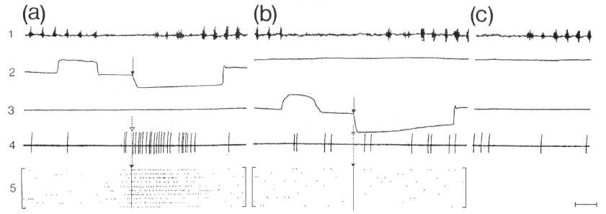
Fig. 1. Activation of L units during food seizure from a feeder at the front wall of the cage. (1) EMG of m. masseter; (2) actogram of behaviour at the front wall; (3) actogram of behaviour at the rear wall (upward deflection = pedal pressing, downward deflection = lowering head into feeder); (4) unit activity; (5) rasters of unit activity (each point represents one impulse, each row one act) plotted at the moment the rabbit's nose crossed the level of the feeder hole (arrows), (a) Food seizure at the front wall, (b) Food seizure at the rear wall, (c) Taking food from experimenter's hand. Horizontal bar on the right = 500 ms.

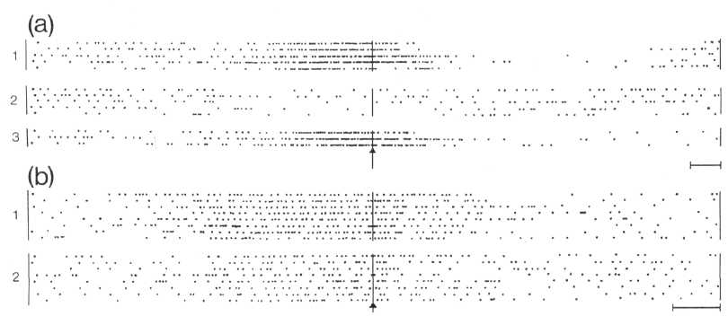
Fig. 2. L units discharging during the approach to and pressing of the pedal at the front wall only (a) or at both walls (b). Rasters plotted at the instant of pressing the pedal (arrows). Numbers on the left indicate different behavioural cycles, (a) Activation during the approach to and pressing of the pedal at the front wall (1,3) but not at the rear wall (2). (b) Activation during the approach to and pressing of pedals at the front (1) and rear (2) walls of the cage. Horizontal bars on the right = 500 ms.

task in the experimental cage which were learned most recently (L units). In the control experiments this subgroup consisted of neurons which were activated during the approach to either feeder, realized by movements to the left at the front or to the right at the rear wall of the cage. Other neurons of this subgroup showed activation during the food seizure, but only under
specific conditions, e.g. when taking food from the right or from the left feeder, but not from the floor or from the experimenter's hand.
Figure 1 shows an example of a neuron which fired during lowering of the head and seizure and grinding of food at the front wall (Fig. 1 a). Activation did not occur during the seizure of the food from the feeder at the rear wall (Fig.

Alcohol and neuron activity in behaviour 261

1 b), during lowering of the head in general or during seizure of the food from the experimenter's hand (Fig. lc).
L units were further classified into neurons which were activated during the approach to either pedal (movement to the left at the rear wall of the cage and movement to the right at the front wall) and/or during pressing of this pedal (Fig. 2 b). Some units showed activations during the approach to and/or pressing of only one pedal (Fig. 2 a).
Finally, to L units belonged also 'place units'. The activation of these units did not depend on the behaviour of the rabbit, but only on the place in which the rabbit was located. These units were classified as L units because of the relation of their activation to the specific environment learned during the acquisition of the experimental task. The parts of the cage which were place-fields for these neurons were localized near the pedals and/or front and rear walls, i.e. the regions where the rabbit acted when learning to press a pedal to get food.
The second subgroup of units consisted of neurons related to the stage of the individual development before learning the food acquisition task in the experimental cage. This subgroup consisted of units which showed activation in relation to different movements of the body and/or head independent of the behavioural context (M units). Figure 3 shows a neuron that was activated in relation to turning of the head to the left in the behavioural cycle near both the front and rear walls (Fig. 3 a, b). It also discharged during passive defensive behaviour when the head was turned to the left by the experimenter (Fig. 3 c).
In the control experiments 28 % of all units were L units (Fig. 4a). The number of M units was significantly smaller (17%, P < 0.05). During one electrode track, an average of 17.1 + 4.6 neurons were encountered. The total number of identified neurons was 564 in 33 tracks.
In the alcohol experiments the number of units detected during one track was significantly (P < 0.001) smaller than in the control experiments, amounting to 10.8 + 3.3 (499 units identified during 46 tracks). The relative number of non-involved units (55%, n = 187) did not differ from that found in the control experiments. However, the relation between L and M units was reversed: The relative number of L units decreased to 11% (P < 0.001), whereas that of
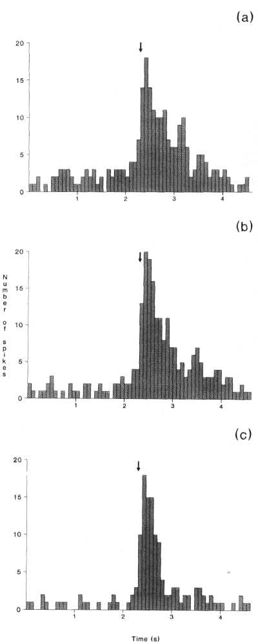
Fig. 3. M unit discharging during turning the head to the left in different behavioural acts. Histograms show summated activity over several behavioural cycles (n > 3) of the moment of the onset of the leftward turn (arrows) during movement from the pedal towards the feeder at the front (a), from the feeder towards the pedal at the rear wall (b) and when the experimenter is moving the rabbit's head to the left (c). Ordinate = number of spikes; abscissa = time (bin width 80 ms).

262 Yu. I. Alexandrov et al.

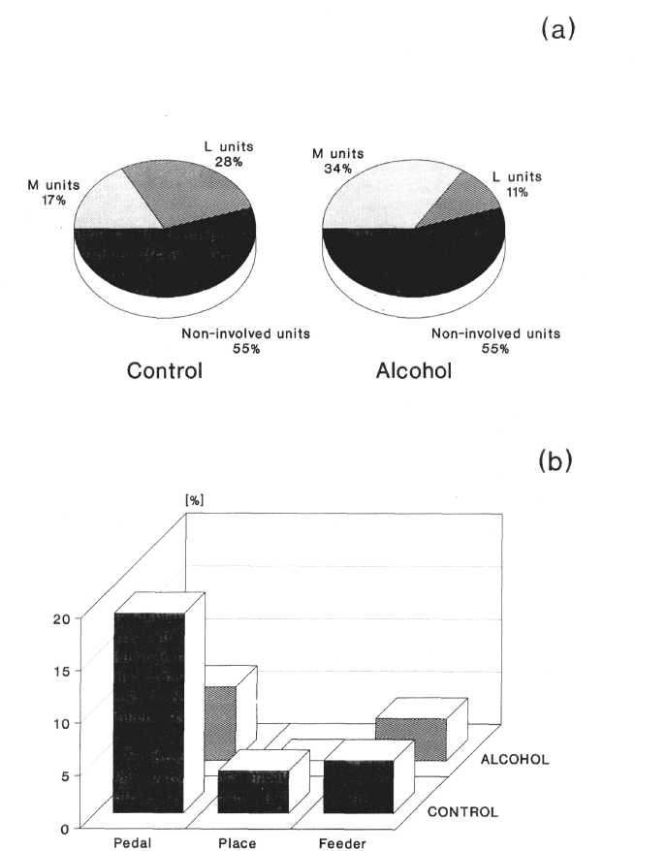
Fig. 4. Relative number of different units in control and alcohol experiments, (a) Non-involved, M and L units, (b) Subgroups of L units: pedal, place, and feeder.

M units increased to 34% (P < 0.001), the latter percentage being significantly (P < 0.001) larger than the former (Fig. 4a). This change was typical of all individual animals (Fig. 5).
In addition to the reversed relation between L and M subgroups, there was also a change in the relative number of units with different types of behavioural specialization within L units in the alcohol experiments (Fig. 4b). In the control experiments this subgroup consisted of 19% L units that were activated during the approach to
and/or pressing of pedals, 4% 'place units' and 5% units which were activated during the food seizure (feeder units). In the alcohol experiments the number of units of the last type did not change significantly, while the number of units of the first two types decreased to 7% (P< 0.005) and 0% (P < 0.05) respectively. Thus the reduction in the relative number of L units was mainly the result of a decrease in the number of units with the first two types of specialization.

Alcohol and neuron activity in behaviour 263

In the alcohol experiments the M subgroup was, in addition to the unit types found in the control experiments, composed of units which were activated during the food seizure. In contrast to those L units which were also activated during the food seizure, but only under specific conditions, these neurons were activated during reaching for the food and its seizure in general. An example of such a unit is presented in Fig. 6. It was activated not only during the food seizure from both feeders (Fig. 6 a, b), but also during the seizure of food from the experimenter's hand (Fig. 6c). These neurons were classified as M units because their specialization with respect to the act of non-liquid food seizure is formed during early stages of postnatal ontogeny (Alexandrov 1989, Alexandrov et al. 1990).
The results presented above indicate that the behavioural disorders in the alcohol experiments were related to a change in the pattern of specialization of activated neurons, i.e. to a change in the relation between the number of L and M units. As the characteristics of the behaviour near the front and rear walls were different, we also compared the specialization pattern of neurons which were activated in the 'preferred' and 'non-preferred' behavioural cycles. In spite of the fact that the number of behavioural mistakes differed between the front and rear walls in both the control and alcohol experiments, the relation between the number of L and M units was almost identical for both cycles. In the control experiments 34 L units and 29 M units were activated in the preferred cycle, and 33 L and 29 M units in the non-preferred one. In the alcohol experiments 13 L and 62 M units were activated in the preferred cycle and 12 L and 63 M units in the non-preferred one.
To estimate the differences in the activations during the different phases of the behavioural cycle at the preferred and non-preferred wall, an ' overall picture' of the activations of the units during each behavioural cycle was plotted. The percentage of activations in each successive behavioural phase was calculated in relation to the total number of activations during the animal's behaviour near the front and rear walls of the cage in the control and alcohol experiments (Fig. 7).
Analysis of the activity at the preferred wall (Fig. 7 a) revealed that in the alcohol experiments
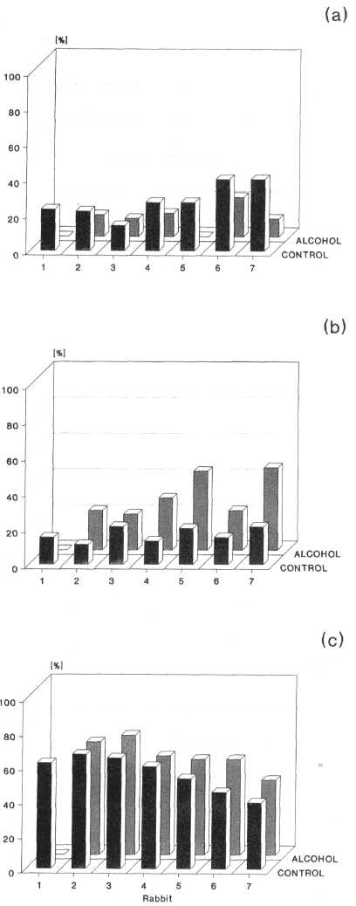
Fig. 5. Relative number of L (a), M (b) and non-involved (c) units for each individual rabbit in control and alcohol experiments.
the number of activations during the approach to and pressing of the pedal decreased significantly, while the number of activations during food

264 Yu. I. Alexandrov et al.

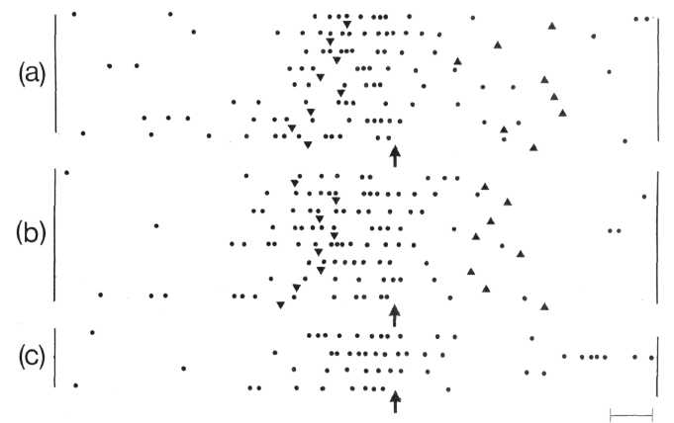
Fig. 6. Activation of M unit during the food seizure from a feeder near the front (a) and rear (b) wall and from the hand of experimenter (c). Rasters plotted from the onset of EMG activation of m. masseter (arrows) that corresponds to closing the mouth during food seizure. Triangles indicate the instant of crossing the level of the hole of a feeder during lowering (V) and lifting (^) the head from feeder. Horizontal bar on the right = 200 ms.

seizure increased significantly (P < 0.05). The tendency for the number of activations to increase was also noticed during food grinding. The analysis of activations at the non-preferred wall (Fig. 7 b) showed a decrease only during pedal pressing (P < 0.05). In the control experiments, plotting ' overall pictures' of the activations with no relation to the side preference (i.e. better or worse performance at the front or rear wall) showed a similar change of activations for only one phase of behaviour near both walls.
When the measured depth of the localized neurons and the thickness of the cortical layers were compared it was found that in the control experiments 12% of the 79 neurons localized in the upper cortical layers belonged to M units, 27% to L units, and 61% to the non-involved units. Of the 87 neurons localized in the lower cortical layers, 20% belonged to M units, 31% to L units and 49% to non-involved units. There were no significant differences in the number of neurons belonging to each type of unit between the upper and lower cortical layers.
In the alcohol experiments 33% of the 89 neurons localized in the upper cortical layers belonged to M units, 5% to L units and 62% to
non-involved units; 33 % of the 86 neurons in the lower layers belonged to M units, 17% to L units and 50% to non-involved units. The number of L units in the lower cortical layers was significantly (P < 0.01) larger than in the upper ones. (The number of units with defined localization was somewhat smaller than the total number of neurons analysed, because for some units that were recorded during the upward movement of the microelectrode the precise localization could not be estimated.)
In the alcohol experiments as compared with the control experiments, the relative number of M units was significantly larger in both the upper (P < 0.001) and lower (P < 0.05) cortical layers. In contrast, the number of L units was significantly smaller in the upper (P < 0.001) as well as in the lower (P < 0.05) layers.
Histological analysis of the contralateral limbic cortical regions which were symmetrical to the recording site revealed no neuronal damage.
DISCUSSION
The total number of units which were encountered during a microelectrode penetration decreased from the control to the alcohol

Alcohol and neuron activity in behaviour 265

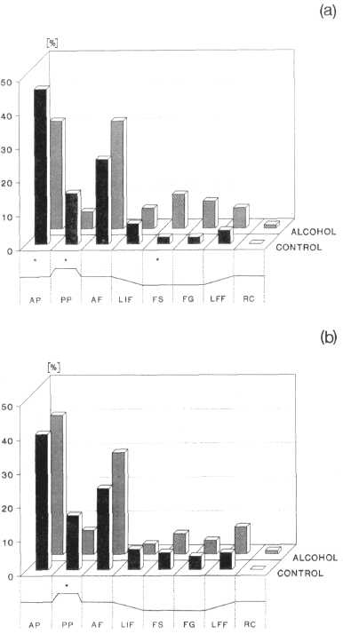
Fig. 7. 'Overall picture' of activations of units during behaviour at the 'preferred' (a) and 'non-preferred' (b) wall. Ordinate: number of activations as a percentage of the total number of activations observed in M and L neurons in control and alcohol experiments. Total number of activations in control = 114 and 121 near the 'preferred' and 'non-preferred' wall respectively, and in alcohol = 141 and 128 near the 'preferred' and 'non-preferred' wall respectively. The abscissa shows phases of the behavioural cycle: approach to pedal (AP), pedal pressing (PP), approach to feeder (AF), lowering head into feeder (LIF), food seizure (FS), food grinding (FG), lifting head from feeder (LFF) and regular chewing (RC). The level of significance for the difference in the number of activations at the given phase in control as compared with alcohol: *P < 0.05.
experiment by approximately one-third. However, the relative numbers of involved and non-involved units did not change. Consequently, the reversed relation between the number of L
and M units in the control and alcohol experiments indicates that ethanol influenced differently neurons with different behavioural specialization.
In cats it has been shown that an acute administration of ethanol in a dose considerably higher than in the present work does not cause any macro- or microstructural damage in the cortical or subcortical areas (Sutko & Weinberger 1979). Histological analysis of the contralateral sites of limbic cortex in the present work also failed to reveal any microstructural neuronal damage. Therefore the change in the pattern of behavioural specialization of the neurons from the control to the alcohol experiments was the result of some functional changes in the organization of the activity of the neurons.
There are three possible explanations for the change in the relative number of M and L units: the absolute number of M units activated during behaviour could have increased while the number of L units decreased; the number of L units could have decreased while the number of M units stayed constant; or the number of both units could have decreased, but that of L units relatively more. Statistical examination of the data supported the second interpretation. We predicted the number of M units assuming that this number remained constant when the total number of active units in the cortex decreased by one-third. This theoretical value did not differ statistically from the experimental value. However, the theoretical value for the number of L units exceeded the experimental value significantly. Thus after acute administration of ethanol the absolute number of L units decreased, but the absolute number of M units did not change. Consequently, disturbances in the food acquisition behaviour after acute administration of ethanol correlate with a decrease in the number of L units in the limbic cortex.
The comparison of the types of L units between the control and alcohol experiments also showed the same regularity in the effect of ethanol: The decrease in the number of L units in the alcohol experiment was mainly the result of a decrease in the number of units which showed activations related to the pedals or places in the cage. Such units belong to systems which were formed during the most recently learnt part of the food acquisition task. As the learning process was always started by giving food from the feeders without pedal pressing, the units

266 Yu. I, Alexandrov et al.

activated by the feeders belong to systems older than those activated by the pedals, and the number of former units stayed approximately constant.
In the control experiments M, L and non-involved units were similarly represented in the upper and lower cortical layers. It may be supposed that all these units involve morphologically different neurons: small cellular elements in the upper, and large pyramidal cells in the lower, layers. The percentage of the non-involved units in the lower and upper layers did not change in the alcohol experiments as compared with the control ones. The percentage of M-unit neurons increased, while that of L-unit neurons decreased in all layers. However, while the percentage of M units in both the control and alcohol experiments did not differ between the upper and lower layers, the percentage of L units in the alcohol experiments was significantly larger in the lower than in the upper layers. This was probably due to a more marked depressive effect of ethanol on small L neurons of the upper layers than on the large L neurons of the lower layers of the limbic cortex. Thus the depressive influence of ethanol on the neurons with the given type of specialization (L) could depend on the morphological type of neuron.
Can then the selective depressing influence of ethanol on L units be generalized to different species and different forms of behaviour ? Chapin et al. (1986) showed that an acute administration of ethanol reduced the difference between the responses of the cortical SI neurons of the rat to stimulation of their receptive fields during three behavioral situations: rest, defensive behaviour and locomotion. Their result can be explained on the basis of a theory which we put forward previously and tested experimentally (Alexandrov 1989). The dependence of the responses of the units on the behavioural situation seems to result from the fact that they must adjust their activity in accordance with the activity of different sets of units in different behavioural situations. Differences between these sets of units may be the result of the selective activation of different L units in different behavioural situations. The increased similarity of the responses of the activated units in all the behavioural situations studied after administration of ethanol, as in the experiments of Chapin et al. (1986), could then arise from the
suppression of certain L units. The decrease in the number of non-involved units after ethanol administration might also be because such L units belonged to the group of non-involved units which did not have any constant relation to food acquisition behaviour in our experimental situation but which were related to some other newly learned behaviour.
Selective sensitivity to ethanol of units belonging to new systems could explain the phenomenon of the effect of ethanol on the memory of man and animals: the most pronounced influence of ethanol is on the acquisition, storage and use of newly learned material (Alkana & Malcolm 1986).
The relation between the number of units with different behavioural specialization is probably a very basic characteristic of neural integration subserving behaviour in normal conditions (relation: L > M) and under the influence of alcohol (relation: M > L). In this study, this relation did not depend on whether the cycle of behaviour was preferred or non-preferred in either the control or the alcohol experiment. However, the preferred and non-preferred side correlated with the temporal organization of the unit activity in relation to the phases of the behaviour (see the overall pictures of activations). When the control and alcohol experiments are compared, there are more differences in the overall picture in the preferred than in the non-preferred cycle.
Attempts to define the functional and structural characteristics of neurons which determine the influence of ethanol on the activity of a given unit have suggested many factors: involvement in poly- or monosynaptic circuits, mediator sensitivity, characteristics of transmembrane channels, etc. (Faber & Klee 1977, Zornetzer et al. 1982, Ksshii et al. 1984, Mereu & Gesse 1985, Chapin et al. 1986). However, although each of these criteria, e.g. poly- or monosynaptic connection of a neuron with a certain input, can predict the effect of ethanol in a particular brain structure, they fail to predict an effect in another structure (Ksshii et al. 1984). The results of the present study have demonstrated the selective action of ethanol on neurons which have a particular behavioural specialization. Therefore it may be that the influence of ethanol on neurons subserving a given behaviour is determined by specific sets of the aforementioned and other characteristics (e.g. morphological

Alcohol and neuron activity in behaviour 267

type of neuron) which correspond to the behavioural specialization of these neurons.
Neural activity during behaviour results in the achievement of the functional system for which the particular neuron is specialized; when the result is achieved during the given behavioural cycle the activity of the neuron stops (Shvyrkov 1980). Consequently, the reduced number of L units in the alcohol experiments indicates that ethanol has an effect on the neurons of the new systems that is comparable to the effect of achieving the behavioural result mediated by these systems, i.e. alcohol results in the cessation of activity of many units.
In addition to its direct influence on neuronal membranes, ethanol also acts indirectly by altering the activity of other neurons at almost all metabolic stages (Komissarova et al. 1986). This indirect influence is determined by the 'environment' of the neuron, i.e. the characteristics of the mediator and receptor systems and the blood circulation of the brain structure and connections of the neuron (Kalant 1975, Mereu & Gesse 1985, Wayner et al. 1975, Zornetzer et al. 1982). It appears that the cessation of neural activity results from a change in the aforementioned (and probably on some other) factors of the neuronal environment. Presumably ethanol, through a direct as well as indirect influence on neurons with all types of specializations, forms an 'environment' which is somewhat similar to that which is formed by these systems in the process of realization of the behaviour.
This work was supported by The Academy of Sciences of the USSR and by The Finnish Foundation for Alcohol Studies. We thank Sirpa Tornberg for help in the final preparation of the manuscript.
REFERENCES
Alexandrov, Yu.I. 1989. Psychophysiological Significance of the Activity of Central and Peripheral Neurons in Behaviour. Science Press, Moscow (in Russian).
Alexandrov, Yu.I., Grinchenko, Yu.V., Svetlaev, I.A. & Abrashitov, O.H. 1989. On the problem of factors determining the effects of acute ethanol injection upon the realization of behaviour. J Higher Nerv Activ 39, 1149-1151 (in Russian).
Alexandrov, Yu.I., Grinchenko, Yu.V. & Jarvi-lehto, T. 1990. Change in the pattern of behavioural specialization of neurons in the motor cortex of the rabbit following lesion of the visual cortex. Ada Physiol Scand 139, 371-385.
Alkana, R.L. & Malcolm, R.D. 1986. Comparison of the effects of acute alcohol intoxication on behavior in humans and other animals. In: K. Eriksson, G. Sinclair & K. Kiianmaa (eds.) Animal Models in Alcohol Research, pp. 193-268. Academic Press, New York.
Anokhina, I.P. 1984. Disorders in dopaminergic system during alcoholism. In: G.V. Morozov (ed.) Biological Basis of Alcoholism, pp. 25-31. Ministry of Health Press, Moscow (in Russian).
CHAPIN, J.K., SORENSEN, M.S. & WOODWARD, D.J.
1986. Acute ethanol effect on sensory responses of single units in the somatosensory cortex of rats during different behavioral states. Pharmacol Biochem Behav 25, 607-614.
Cloninger, C.R. 1987. Neurogenetic adaptive mechanisms in alcoholism. Science 236, 410-416.
Descarries, L., Doucet, C, Lemay, В., Seguela, P. & Watkins, K.D. 1988. Structural basis of cortical monoamine function. Neurotransmitters and cortical function. In: M. Avoli (ed.) From Molecules to Mind, pp. 321-332. Plenum Press, New York.
Faber, D.S. & Klee, M.R. 1977. Action of ethanol on neuronal membrane properties and synaptic transmission. Alcohol and opiates. In: K.Blum (ed.) Neurochemical and Behavioural Mechanisms, pp. 41-63. Academic Press, New York.
Grupp, L.P. & Perlanski, E. 1979. Ethanol-induced changes in the spontaneous activity of single units in the hippocampus of the awake rat: dose—response study. Neuropharmacology 18, 63-70.
Kalant, H. 1975. Direct effects of ethanol on the nervous system. Fed Proc 34, 1930-1941.
Klemm, W.R., Mallari, C.G., Dreyfus, L.R., Fiske, J.C., Forney, E. & Mikeska, J.A. 1976. Ethanol-induced regional and dose response differences in multiple unit activity in rabbits. Psychopharma-cology 49, 235-244.
KOMISSAROVA, I.A., ROTENBERG, V.S. & MASTER-
opulo, A.P. 1986. Mechanisms of Ethanol Influence and Approaches to the Corrections of Metabolic Disorders during Chronic Alcoholization. Publication of Institute of Scientific and Technical Information of the Soviet Union, Moscow (in Russian).
Kriganovsky, G.N. & Evseev, V.A. 1988. Neuro-pathophysiologic and neuroimmunopathologic approaches to the understanding of mechanisms and developing principles of pathogenetic therapy of alcoholism. Proc USSR Acad Med Sci 10-14 (in Russian).
Ksshii, S., Ito, J., Matsuoka, I., Sasa, M. & Takaori, S. 1984. Effects of ethanol applied by electrosmosis on neurons in the lateral and medial vestibular nuclei, jfpn J Pharmacol 36, 153-159.
Mereu, G. & Gesse, G. 1985. Low doses of ethanol inhibit the firing of neurons in the substantia nigra, pars reticulata: a GABAergic effect. Brain Res 360, 325-330.

268 Yu. I. Alexandrov et al.
Rogers, J., Siigins, G.R., Schulman, J.O. & Bloom, Th. G. 1986. Rabbit circulate cortex: cyto-
F.E. 1980. Physiologic correlates of ethanol in- architecture, physiological border with visual cor-
toxication, tolerance, and dependence in rat cer- tex, and different cortical connections of visual,
ebellar Purkinje cells. Brain Res 196, 183-198. motor, postsubicular and intracingulate origin. J
Shvyrkov, V.B. 1980. Goal as a system-forming Cotnp Neurol 248, 74—94.
factor in behavior and learning. In: Wayner, M.J., Ono, T. & Nolley, D. 1975. Effects
R.F. Thompson, L.H. Hicks & V.B. Shvyrkov of ethyl alcohol on central neurons. Pharmacol
(eds.) Neural mechanisms oj Goal-Directed Behaviour Biochem. Behav 2, 499-506.
and Learning, pp. 199-220. Academic Press, New Zornetzer, S.F., Walker, D.W., Hunter, B.E., &
York. Abraham, W.C. 1982. Neurophysiological changes
Sutko, M.H. & Weinberger, N.M. 1979. Effects of produced by alcohol. Biomedical Processes and
ethanol on the cochlear nucleus and auditory cortex Consequences of Alcohol Use, pp. 95-128. US
of the cat. jf Studies on Alcohol 40, 799-822. Government Printing Office, Washington, DC.
Vogt, B.A., Sikes, R.W., Swaldow, H.A. & Weyand,

