Russian children and teenagers draw Europe and a European person

Margarita Volovikova
Russian Academy of Sciences, Institute of Psychology,

13 Yaroslavskaya, Moscow 129366, Russia
volovik@psychol.ras.ru

The method of drawing Europe (Axia G., Bremner J.G., Deluca P. and Andreasen G. (1998) was used to study the geographical representations of Russian children and teenagers about the boundaries of Europe. 172 schoolchildren aged from 8 to 16 years old (152 schoolchildren from Moscow region and 20 from Cossacks stanitsa Veshenskaya) drew “the map of Europe”. In addition, they were asked to draw “a European” and to mark on their map the country and the place where the European lives. They were also asked what language the European speaks. The drawings of the European were analysed using the principles of projective drawing methods. The analysis of the drawings revealed that Russian children, both from the Moscow region and Cossacks from the Don’s stanitsa, have similar representations of Europe and Europeans. This finding can be explained by reference to the mutual cultural context which these children share. The most popular European country was Great Britain, the country which is the most geographically distant from Russia. The same is true for the English language. Russian gained second place. The European lives mostly in Russia, i.e. Russia in children’s opinions is not only a geographical but also a socio-cultural part of Europe.

Children’s and teenagers’ representations about the world around them depend on many components: cognitive development, social and political conditions, knowledge and experience of a child. The history of concrete researches of geographical representations go back to Jean Piajet's studying of children's judgements about the country (Piajet, 1928). Asking Geneva children: "Are you Swiss?","Are you from Geneva?" and "Are you Swiss and Genevian at the same time?” Piajet has come to the conclusion that the most difficult for a child is to correlate the whole with the parts. A seven-year old child can say: “Country - is another city”, other child asserts that Geneva is in Switzerland, but Geneva people for him are not “Swiss”. Only at the age of 10-11 years children are able to make a correct representation about Geneva - Switzerland relation.
In their cognitive aspects, the concept of “Europe” correlates with the concept of “European” as a whole to its parts, in other words the countries which are situated in Europe with the people who live there. The main cross-cultural investigation studied children’s representations of their own country, their nation, other nations and the international communities children attribute to themselves (e.g. Europeans, Slavs, etc.). The goal of the present study was to see how these general concepts are reflected in the children’s imaginative sphere. Geographically, Russia is situated in Europe and Asia simultaneously, and it does not have the usual water boundaries which divide other parts of the world. How does this fact affect children’s representations? And where is Europe for Russian children? Do they include in Europe their own settlement, the European part of Russia, or the whole of Russia? What European countries do they know? And what view of the world do Russian children have?
Our investigations were based on the work of Axia G., Bremner J.G., Deluca P. and Andreasen G. (1998) Children drawing Europe: The effects of nationality, age and teaching (British Journal of Developmental Psychology, 16, 423-437) where they compared the drawings of European map made by 8-10-year old children from Scotland, England, Spain, Switzerland, Southern and Northern Italy. In authors’ opinion, research has shown the value of a geographical position of the country the child live and, naturally, a role of teaching of geography at school. It turned out that children know better those countries that border with their native. Practically all the children (from 100 up to 90 % of children in each group) have represented their own state on the map of Europe. G. Axia, J.G. Bremner, P. Deluca and G. Andreasen made the conclusion about the influence of socio-cultural traditions on the development of geographical representations. In their article we can find the following data. There are France, Spain, Yugoslavia and Russia in more than half drawings of children from Northern Italy. More than in half of children drawing from northern Italy there are France, Spain, Yugoslavia and Russia. More than half of children from Scotland has represented France, Spain, Germany and Italy. More than 50% of English children have drawn France, Ireland, Spain, Norway, Germany and Italy. More than half of children from Switzerland has represented Italy, Germany, France and Spain. These data concerned only 10-years children as due to the cognitive aspects 8-years frequently confuse cities with the countries. It was interesting for us to analyse Russian children representation of European world on the map. Besides it was important to find out the meaning of the word “European” for Russian children: where does the European live? What language does he speak? How does he look like? The answers on these and other questions were the aim of our investigations.

Hypothesis.
We started with several assumptions:
- Geographical representations about Europe and Europeans of children from various regions of Russia should have much in common, that is caused by uniform cultural space: traditional cultural, economic and other relations with other peoples of Europe.
- The geographical affinity or remoteness of other states has smaller value, than cultural relations established historically.
- The qualitative analysis of the children’s drawings allowed revealing their attitude to the theme Europe and Europeans.
Taking into account the modern curriculum on geography at ordinary Russian schools, we can expect the knowledge of the map of Europe only from pupils of 10^{-th} form (15-16 years old), the others can have most common representations.

Methods
We took G. Axia’s and his colleagues’ research (Axia at al., 1998) as the basis of the experiment realization. In this work they used the method of drawing the map of Europe by heart. We completed this task with the request to draw “European” and than to mark on the map:
а) The place a European lives;
b) The place a child lives;
c) Places a child has ever travelled;
d) A child also asked what language the European speaks.
It was allowed to draw in colour pencils and felt-tip pens. The experiment passed partially in the same conditions, as during the research of our colleagues, that is children fulfilled the task in the classroom, sitting one person at a school desk. However approximately one third of children carried out the task and gave the answers individually.
The analysis of children’s drawings and answers differed a little: we counted only % of children in the given group, answered in that or another way. Of 3 parameters pointed out by G. Axia at all. (the list of the countries, relative position and contours) we considered only the list of the countries.
Drawing of European was analysed as projective: we considered the arrangement on a sheet, presence - absence of hands, face, carefulness of a portrayal etc.

Examinees
Two groups of children and teenagers participated in the research:
1. 20 people from Cossack village Veshenskay: 13 boys – studying at Cossack school age 10-15 y.o. and 7 students of pedagogical college 15-16 y.o. (1 boys and 6 girls)
2. 152 people in the age of 8-15 from Moscow region, villages Kupavna and Chernogolovka (the author thanks Olga Kuznetzova for the help with research realization in Chernogolovka).

The analysis of drawings and statements

The children’s maps of Europe contained the following: the countries that a child was able to mark; other countries and regions of his/her own country which he/she has visited; the location of the country and the place where the child lives in relation to the boundaries of Europe; the place where the European lives according to the child’s opinion; some attributes connected with the cognitive difficulties of the given task for the child (the separate portrayal of Europe; the “island” location of different countries and cities, for example, island France, island Greece, etc.; the scheme of local surroundings; a drawing instead of a map, etc.). The drawing of the European was judged on a scale running from 1 to 5 (like school marks).
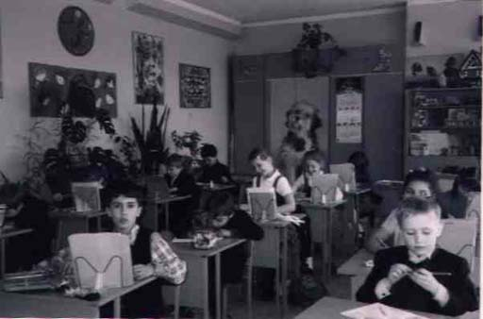 | Children of Moscow region Kupavna draw Europe and Europeans

Results
The analysis of the maps of Europe drawn by the children showed that the collective portrayal of Europe includes all European countries (and the countries of some other continents). The main difficulty for the younger children was in dividing Europe from Eurasia. The drawings of the 8-year-old children revealed similar characteristics as the drawings of children of the same age from Western Europe: they portrayed cities, “Europe”, or the scheme of local surroundings more frequently. The results gained by analyzing the maps of Europe drawn by children of other ages (except 8-year-old ones) are given below in the Table 1.

Table 1. The main European countries represented by children from the Moscow region and stanitsa Veshenskaya in their drawings “the map of Europe”.

The main European countries drawn by children from the Moscow region | The main European countries drawn by children from stanitsa Veshenskaya
Great Britain 52,3% | Great Britain 45%
France 49,5%  Germany 49,5% | France 40%  Germany 35%
Italy 46,8 | Ukraine35%
Spain 41,3%  Ukraine 36,7% | Belarus30%  Russia30%
Finland 30,3%  Sweden 28,4%  Russia 28,4% | Finland 25%  Sweden 20%  Italy 20%
Portugal 26,6%s  Poland 25,7%  Greece 25,7%  And others | Lithuania 20%
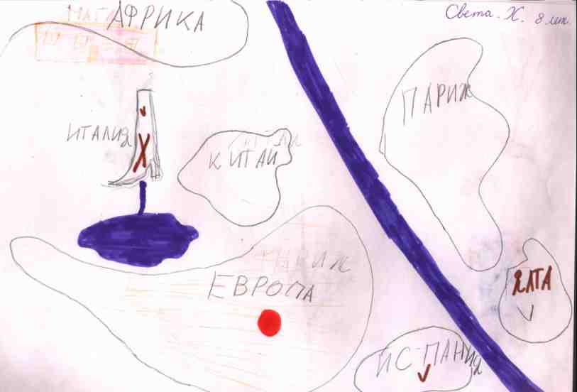 |  | 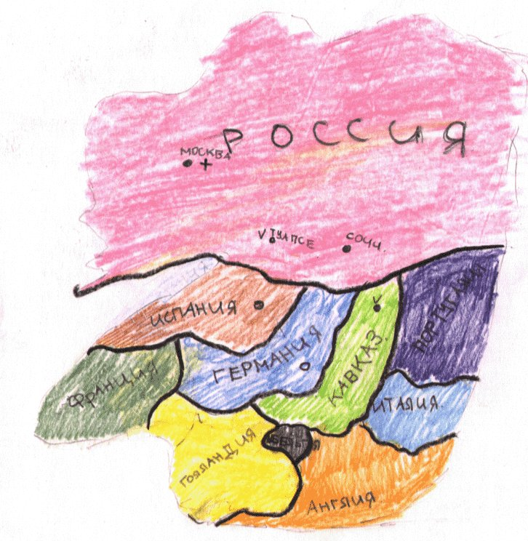
The Island Paris and the Island Europe on the drawing of the girl 8 y.o. |  | The image of Europe of 11y.o. boy from Moscow Region

Here there are some examples of the drawings typical for each age and territorial group of children. Certainly, to make more definite conclusions it is necessary to carry out an additional research: to compare children living in other regions of Russia (and not only in its European part). Experimental groups should be equalised as far as possible concerning ages and gender of children. However results offered here represent especial interest. The matter is that Cossacks are Russian people, but due to the historical events their way of life has been connected with military service and the protection of Russian borders. Although the Cossacks were subjected to persecutions and prosecutions after the revolution, but now it experiences the process of revival. We expected, that young Cossacks would have less problems, connected with the theme "Europe and Europeans". The analysis of the drawings of "European" illustrates, from our point of view, some confirmation of our expectations.

Table 2. The results of the analysis of the drawings “European” and “The map of Europe” made by the children from the Moscow region and stanitsa Veshenskaya.

The results of the analysis | The answers and drawings made by children from the Moscow region | The answers and drawings made by children from stanitsa Veshenskaya
Country  Where the European  Lives | Russia – 27,6%  Great Britain – 14,5%  “Europe” – 8,6%  France – 7,9%  Asia countries – 7,2%  Spain – 5,3%  Germany – 3,3% | Russia – 35%  Great Britain – 15%  “Europe” – 15%  France -- 5%  Germany – 10%  Ukraine – 10%  USA – 5%
Language which the European speaks | English – 30,3%  Russian – 26,3%  European – 10,5%  Spanish – 4,6%  German – 3,3%  Italian – 2,6% | English – 35%  Russian – 30%  German – 10%  French – 5%  European – 5%  Ukrainian – 5%
The appearance of the European (in points from 5 to 1) | (5) – 52,6%  (4) – 14,5%  (3) – 19,7%  (2) – 7,2 %  - – 6,6% | (5) – 40%  (4) – 25%  - – 25%  - – 5%  - – 0
The Cossack children produced fewer drawings of the European revealing problems.
The European speaks mainly in English (Russian gained second place). Most often, the European lives in Russia (with GB being in second place, with the other places being distributed across almost all the countries of the whole of Europe).
These are general facts. Now we would like to touch specific features related to the age, place of living and the experience gained by the children while traveling.
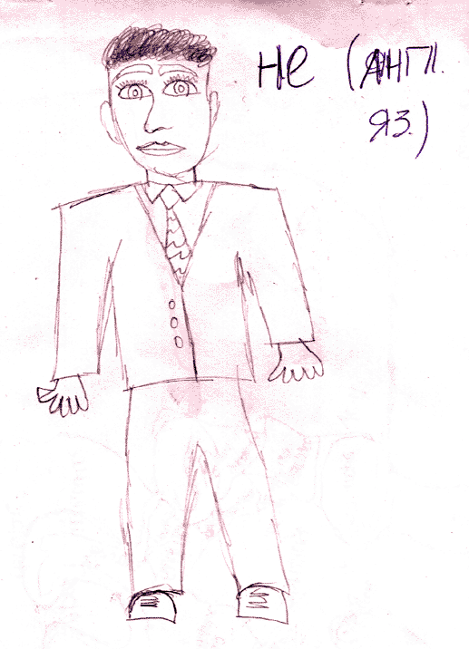 | 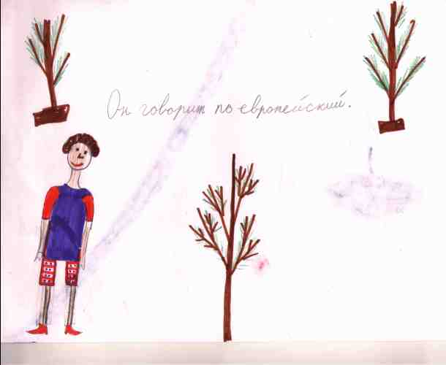
European-Englishman, 15 y.o. boy | European on the drawing 8 y.o. girl
Child’s representation of two islands: Europe-island and Russia-island, on the ocean background can mean that Europe is something separate and different from Russia as well as the cognitive problems. There are also just simple pictures and drafts. There can be two possible attitudes to Europe – inclusion or separation. The choice between these two attitudes expressed in the drawings and answers depends upon the personal attitude of the child. If he is only the inhabitant of “Veshky”, Rostov and the whole world itself are somewhere far away, it means that I am the European, and this is the inhabitant of Veshky, most likely – the Cossack. We give the examples of the typical drawings of Cossacks made by different boys and girls.
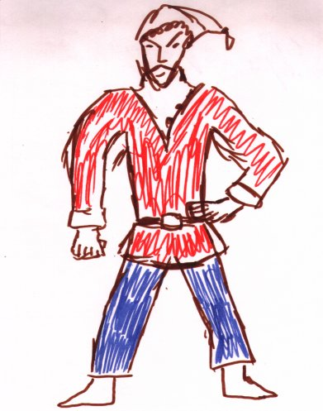 | 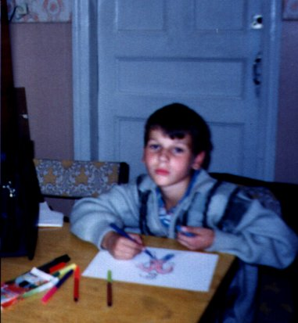
Cossaks-European lives in Vesheshenskaya | …and the author of picture

The experience of travelling European countries and Russia had the positive effect on the children’s drawings of the map. Thus the children from Kupavna (where there are a lot of military sailors) marked Severomorsk, Vladivostok, Murmansk and Petropavlovsk-on-Kamchatka on their maps. Northern routes allowed to represent better some Scandinavians countries, Japan, Mongolia and China (sometimes including them in the Europe).
There are a lot of confusions connected with the Ural Mountains. The knowledge that it is the border between Europe and Asia frequently appeared to be insufficient to reflect this knowledge spatially. The Urals was represented almost in all the possible places! Sometimes it coincided with the western boundaries of Russia.

Conclusions
Russian children, both from the Moscow region and Cossacks from the Don’s stanitsa, have similar representations of Europe and Europeans. This finding can be explained by reference to the mutual cultural context which these children share. The most popular European country was Great Britain, the country which is the most geographically distant from Russia. The same is true for the English language. Russian gained second place. The European lives mostly in Russia, i.e. Russia in children’s opinions is not only a geographical but also a socio-cultural part of Europe. Travel experience is beneficial for children in contributing to their geographical representations (children draw the places and the countries which they have visited more precisely).

?The work was supported by INTAS (INTAS-OPEN-97-1363). Presented at Xth European Conference on Developmental Psychology. Uppsala, Sweden, August 22nd-26th, 2001.

