NEUROSCIENCE RESEARCH COMMUNICATIONS, VOL. 21, No. 2 119
LTP IN CINGULATE CORTEX OF FREELY MOVING RATS: DURATION AND MGLUR INDEPENDENCE
Alexander G. Gorkin^{b}, Yuri I. Alexandrov^{b}and Klaus G. Reymannª
ªdepartment of Neurophysiology, Federal Institute for Neurobiology,
P.O.B. 1860, D - 39008 Magdeburg, Germany
^{b}institute of Psychology, Russian Academy of Sciences, Yaroslavskaya 13, 129366 Moscow, Russian Federation
(Accepted June 27, 1997)
ABSTRACT
The role of metabotropic glutamate receptors (mGluR) in synaptic transmission and plasticity of field potentials (fEPs) evoked by subicular stimulation of the cingulate cortex was investigated in freely moving adult rats. Tetanic stimulation with 100 Hz trains caused an enhancement of synaptic transmission in the cingulate cortex which lasted at least 24 hours, and can thus, be regarded as long-term potentiation (LTP). lev. injection of the metabotropic glutamate receptor (mGluR) antagonist (R,S)-a-methyl-4-carboxyphenylglycine (MCPG) did not influence either baseline synaptic transmission or LTP of the fEPs. In contrast to the hippocampus mGluRs of the cingulate cortex seem not to be critically involved in the development of late LTP stages. © 1997 John Wiley & Sons, Ltd.
KEY WORDS
Learning; Long-term potentiation; Cingulate cortex; freely moving rat; metabotropic glutamate
receptor (mGluR).
INTRODUCTION
Long-term potentiation (LTP) is an experimental model of activity-dependent plasticity which is widely used for the investigation of cellular mechanisms of learning and phases of memory consolidation [1,2]. This phenomenon has been most extensively investigated in the hippocampus. However, LTP has also been observed in cortical structures [3-5], which are considered to be the place where the long-term storage of learned information takes place [6]. This process of storage is thought to be conditioned by hippocampal events - it was proposed that hippocampal pyramidal cells have discharge properties that may result in the induction of

120 NEUROSCIENCE RESEARCH COMMUNICATIONS, VOL. 21, No. 2
LTP in their cortical targets [7] and it was shown that a correlation exists between the development of LTP in hippocampus and cortical structures when recording from both structures simultaneously [8].
One of the main target structures of the hippocampal formation is the posterior cingulate cortex, the rostral part of which is thought to play a pivotal role in associative memory functions [9] and which neurons were shown to subserve instrumental learning by the adult animals [10-11]. Subicular-cingulate connections, which have been demonstrated electrophysiologically and morphologically [12], are essential for the involvement of cingulate cortex in mechanisms of learning [13].
Recently, an enhancement of synaptic transmission was demonstrated in the posterior cingulate cortex in vitro and in vivo [ 14] following stimulation of the subicular-cingulate tract (SCT). Two points remain to be clarified, however. Firstly, in vivo LTP data was only briefly characterized and may not correspond closely with the in vitro data. Secondly, due to the short period of analysis, it is not clear whether the potentiation is really a long-lasting one or is only a short-term potentiation (STP) - according to the classification of the phases of LTP expression [1-2]. To resolve this second point, it is necessary to continue the recordings for at least 6 hours after the tetanic stimulation. As the characteristics of synaptic plasticity depend on the behavioral state of the animal [15] it is interesting to investigate the possibility of induction and the properties of LTP in the behaving animal, i.e. in the situation when learning normally occurs.
In this study we investigated field potentials evoked by subicular stimulation (fEPs) of cingulate cortex of freely moving rats for long time periods after tetanic stimulation. The long-lasting nature of LTP in this region allowed us to analyse the involvement of metabotropic glutamate receptors (mGluRs), which are i) also found in the neocortex [16-17] and ii) known to be important for the induction of the late phases of hippocampal LTP [18-19].
MATERIALS AND METHODS
8-week old male Wistar rats (200-300 g) were anaesthetized with sodium pentobarbital (40 mg/kg i.p.) and mounted in a stereotaxic frame. The skull was exposed and bore holes were made according to the stereotaxic atlas of the rat brain [20]. A cannula for i.c.v. injection of glutamate receptor antagonists (P: 0.8, L: 1.6, V: 4.0, all co-ordinates in mm zeroed to bregma and dura) was targeted to the right lateral ventricle. A stimulation electrode (two glued 75 urn platinum-iridium wires in teflon isolation cut at an angle) was placed in the subiculum (P. 6,5, L: 0,5, V: 2.5-3.5). A recording electrode (125 (am platinum-iridium wire) was placed in the deep layers of the posterior cingulate cortex (P: 5,5, L: 0,5, V: 1-2). The rats were allowed one week to recover from surgery. The position of the electrodes was adjusted to obtain the maximal response to SCT stimulation. Bipolar 100 ^sec pulses of 200-400 ^A in a block of 9 testing stimuli with 15 sec interstimulus interval were applied every 15 min. The current for test stimuli was calculated after input/output curve measurement as that giving 40% of the maximal response amplitude. For tetanic stimulation this current was doubled. (R,S)-a-methyl-4-carboxyphenylglycine (MCPG) was injected i.c.v. (200 mM/ 5 fj.l at 1 nl per min to achieve a
NEUROSCIENCE RESEARCH COMMUNICATIONS, VOL. 21, No. 2 121
estimated brain concentration of 500 µM) after 2-hour of baseline recording and 30 min before the the tetanus was applied. At the end of the experiment animals were decapitated and the brains were removed for histological verification of the position of electrodes and cannulae.
RESULTS
The shape of the potentials obtained with test stimuli fit well with the ones observed by Hedberg and Stanton [14] in in vitro and in vivo recordings in the deep layers of the cingulate cortex (Fig.1 B). Injection of the N-methyl-D-aspartate (NMDA) receptor antagonist, AP5 (20 mM in 5 (al injection volume) led to a temporary 25 % inhibition of the responses including the primary negative deflection with peak latency of approximately 3,5 msec after stimuli onset (data not shown). These results are in accordance with findings that NMDA receptors participate in normal synaptic transmission in the neocortex [4-5], unlike in the hippocampus. Due to the baseline effects NMDA receptor involvement in the cingulate cortex LTP was not tested.
12 rats received tetanic stimulation of the SCT in an attempt to produce LTP. As a strong tetanic stimulus we used 6 trains of bipolar 100 Hz stimulation each of 600 msec duration. Intertrain interval was 10 sec. The time curve of changes of the response amplitude after tetanic stimulation is presented in Fig. 1 A. As one can easily see the responses were significantly increased at all timepoints on the day of tetanization and this increase was also significant 24 hours after the tetanization. The increase was more than 20 % in 9 rats from 12. Two of these rats were investigated further after one week. Interestingly, both of these rats still showed 15-20 % potentiation, but were still capable of an extra enhancement upon a second tetanization.
To test the involvement of metabotropic glutamate receptors (mGluRs) in the processes underlying cingulate cortex LTP, we used the broad-spectrum mGluR antagonist MCPG. It has been shown previously that MCPG effectively blocks late LTP, i.e. the transfer of STP to LTP in in vitro preparations of hippocampus [18,19] (but see e.g. [21]) as well as in freely moving rats [19, 22-23]. Five rats from six showed a potentiation after tetanus application and this potentiation lasted at least 7 hours. Compared to vehicle injected LTP controls MCPG led only to a non-significant temporary facilitation of posttetanic values (Fig. 2). It is unlikely that MCPG did not reach its targets in the cingulate cortex since AP5 was effective following the same protocol.
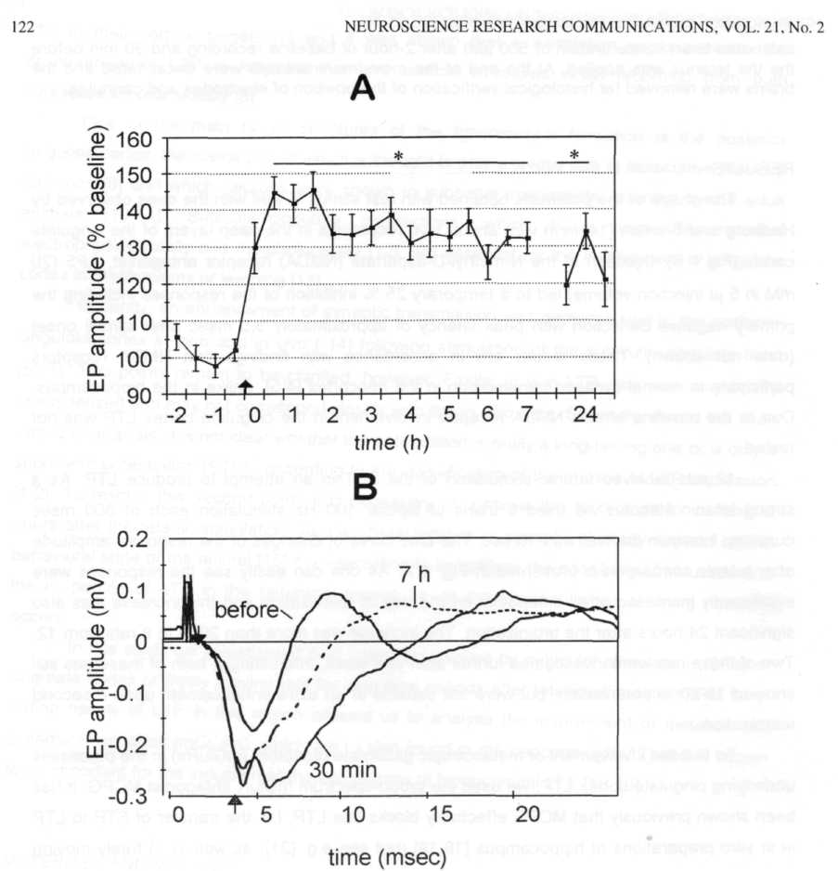
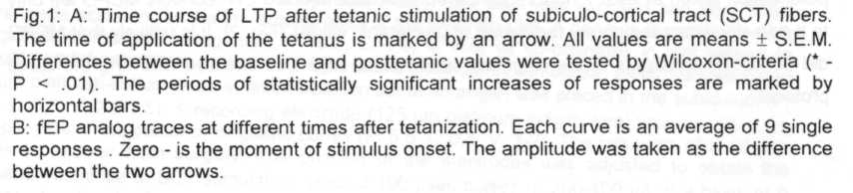
DISCUSSION

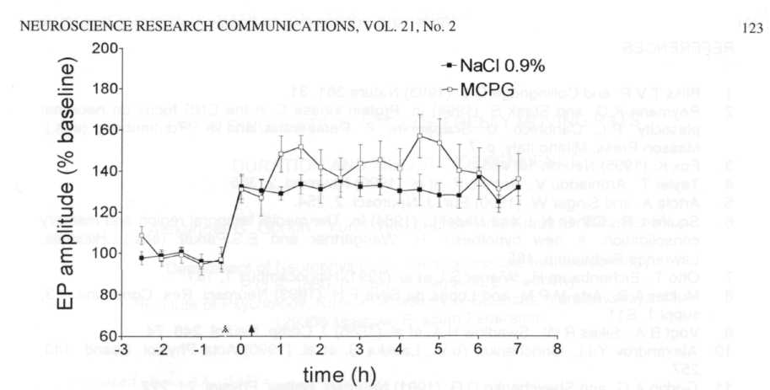
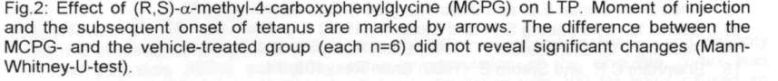
These data show that that tetanus-induced potentiation of the subicular-cingulate tract may be induced in the adult behaving animal and without any additional means to reduce inhibition (no GABA antagonists). This enhancement lasts enough long to be regarded as LTP and potentially to be a cellular mechanism of long-term memory consolidation in the cingulate cortex [10-11, 13]. To test this proposal in a more direct way it may be instructive to combine the investigation of artificially evoked long-term enhancement of synaptic transmission in single units with the study of their role in subserving the acquisition of a new behavioral experience.
Considering the failure of the mGluR antagonist MCPG to block LTP it seems that under the present experimental conditions class 1 and 2 mGluRs are not required for the development of a long-lasting potentiation in the cingulate cortex, in contrast to our results obtained in the hippocampus fCA1) and dentate gyrus [22-23] of freely moving rats. In this structure, it appears that activajon of NMDA receptors and/or voltage gated calcium channels is sufficient to create LTP. We cannot exclude however, that mGluRs can be important if other tetanization parameters are used.

This research was supported by grants of the Deutsche Forschungsgemeinschaft (SFB 426) to K.G.R. and by the Russian Fund of Fundamental Research grant 97-04-48138 to Yu.I.A. and A.G.G.

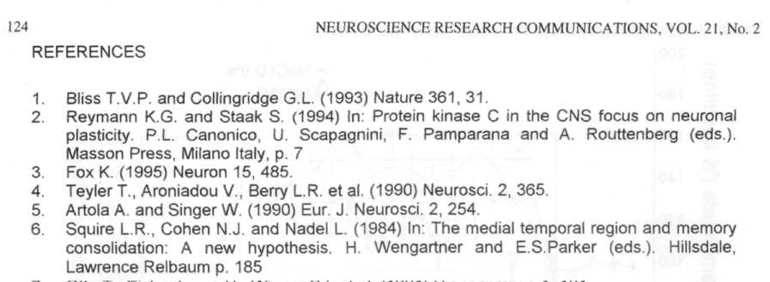
- OttoT., Eichenbaum H., Wiener S.I. etal. (1991) Hippocampus 1, 181.
- Mulder A.B., Arts M.P.M. and Lopes da Silva F.H. (1993) Neurosci. Res. Communic. 13,
suppl 1, S11
- Vogt B.A., Sikes R.W., Swadlow H.A. et al. (1986) J. Comp. Neurol. 248, 74.
- Alexandrov Yu.l., Grinchenko Yu.V., Laukka S. et al. (1990) Acta Physiol. Scand. 140,
257.
- Gorkin A.G. and Shevchenko D.G. (1991) Neurosci. Behav. Physiol. 21, 222.
- Finch DM., Derian EL. and Babb T.L (1984) Exp. Neurol. 83, 468.
- Gabriel M., Sparenborg S.P. and Stolar N. (1987) Exp. Brain Res. 67, 131.
- Hedberg T.G. and Stanton P. (1995) Brain Res. 670, 181.
- Bramham C.R. and Srebro B. (1989) Brain Res. 493, 74.
- Martin L.J., Blackstone CD., Huganir R.L et al. (1992) Neuron 9, 259.
- Romano C, Sesma M.A., McDonald C.T. et al. (1995) J. Comp. Neurol. 355, 455.
- Bashir Z.I., Bortolotto Z.A., Davies C.H. et al. (1993) Nature 363, 347.
- Riedel G. and Reymann K.G. (1996) Acta Physiol. Scand. 157, 1.
- Paxinos G. and Watson C. (1986) The Rat Brain in Stereotaxic Coordinates, Academic
Press, Orlando FL p. 136.
- Chinestra P. Anikstejn Land Ben-Ari Y. (1994) J. Neurophysiol. 70, 2684.
- Riedel G., Casabona G. and Reymann KG. (1995) J. Neurosci. 15, 87.
- Manahan-Vaughan D. and Reymann KG. (1997). Neurosci. 74, 723.

